Nemesio Flores

MEA 201-Monday 4:00-5:40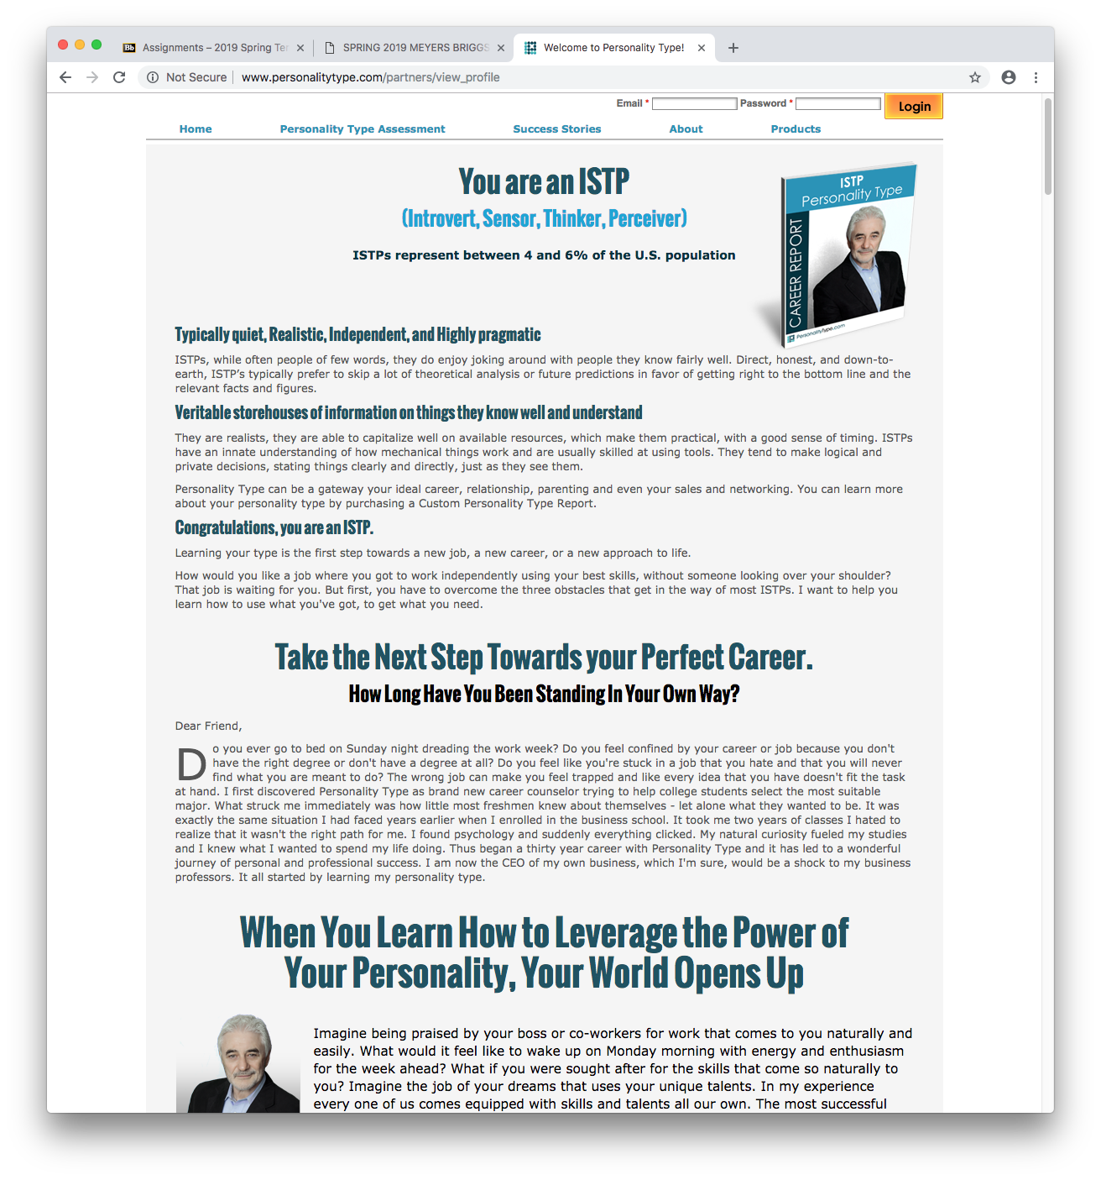

Personality: ISTP